INSTITUTIONAL PROGRAM REVIEW 2009-10
Program Efficacy Phase, Spring, 2010

Purpose of Institutional Program Review

Welcome to the Program Efficacy phase of the San Bernardino Valley College Program Review process. Program Review is a systematic process for evaluating programs and services annually. The major goal of the Program Review Committee is to evaluate the effectiveness of programs, and to make informed decisions about budget and other campus priorities.

The Institutional Program Review Committee is authorized by the Academic Senate to develop and monitor the college Program Review process, receive unit plans, utilize assessments as needed to evaluate programs, recommend program status to the college president, identify the need for faculty and instructional equipment, and interface with other college committees to ensure institutional priorities are met.

The purpose of Program Review is to:
❑ Provide a full examination of how effectively programs and services are meeting departmental, divisional, and institutional goals
❑ Aid in short-range planning and decision-making
❑ Improve performance, services, and programs
❑ Contribute to long-range planning
❑ Contribute information and recommendations to other college processes, as appropriate
❑ Serve as the campus’ conduit for decision-making by forwarding information to or requesting information from appropriate committees

Our Program Review process is two-fold. It includes an annual campus-wide needs assessment in the fall, and an in-depth review of each program every three years that we call the Program Efficacy phase. Instructional programs are evaluated the year after content review, and every three years thereafter, and other programs are placed on a three-year cycle by the appropriate Vice President.

An efficacy team of two disinterested committee members will meeting with you to carefully review and discuss your document. You will receive detailed feedback regarding the degree to which your program is perceived to meet institutional goals. The rubric that the team will use to evaluate your program is included with this e-mail

When you are writing your program evaluation, you may contact efficacy team assigned to review your department or your division representatives for feedback and input. The list of readers is being sent to you with these forms as a separate attachment.

Forms are due back to the Committee Chairs, Efficacy Team and Division Dean by March 22, 2010.
It is the writer’s responsibility to be sure the Committee receives the forms on time.

In response to campus wide feedback that program review be a more interactive process, the committee will pilot a program efficacy that includes a review team who will interviews and/or tour a program area during the efficacy process. Another campus concern focused on the duplication of information required for campus reports. The pilot will incorporate the Educational Master Plan One-Page Summary (EMP Summary) and strive to reduce duplication of information while maintaining a high quality efficacy process. More details on the pilot can be found in the attached file.

Program Efficacy, Spring 2010

Complete and attach this cover sheet as the first page of your report.

Program Being Evaluated
RTVF

Name of Department:
RTVF

Name of Division
Library, Learning Resources and Communication Media

Name of Person Preparing this Report Extension
Patti Wall; Diane Dusick

Name of Department Members Consulted
Diane Dusick, Kamuela Kalanui, James Rippetoe

Name of Efficacy Team
Richard Jaramillo; Kay Weiss

Program Review Committee Representatives
Celia Huston

Work Flow | Due Date | Date Submitted
Date of initial meeting with department | 2/24/2010 | Click here to enter text.
Final draft sent to the dean | Click here to enter text. | Click here to enter text.
Report submitted to Program Review Team | Click here to enter text. | Click here to enter text.
Meeting with Review Team | Click here to enter text. | Click here to enter text.

Staffing
List the number of full and part-time employees in your area.
Classification | Number Full-Time | Number Part-time, Contract | Number adjunct, short-term, hourly
Managers | 0 | 0
Faculty | 1 | 0 | 2 (3 in fall)
Classified Staff | 0 | 0 | 0
Total | 1 | Click here to enter text. | 2 (3 in fall)

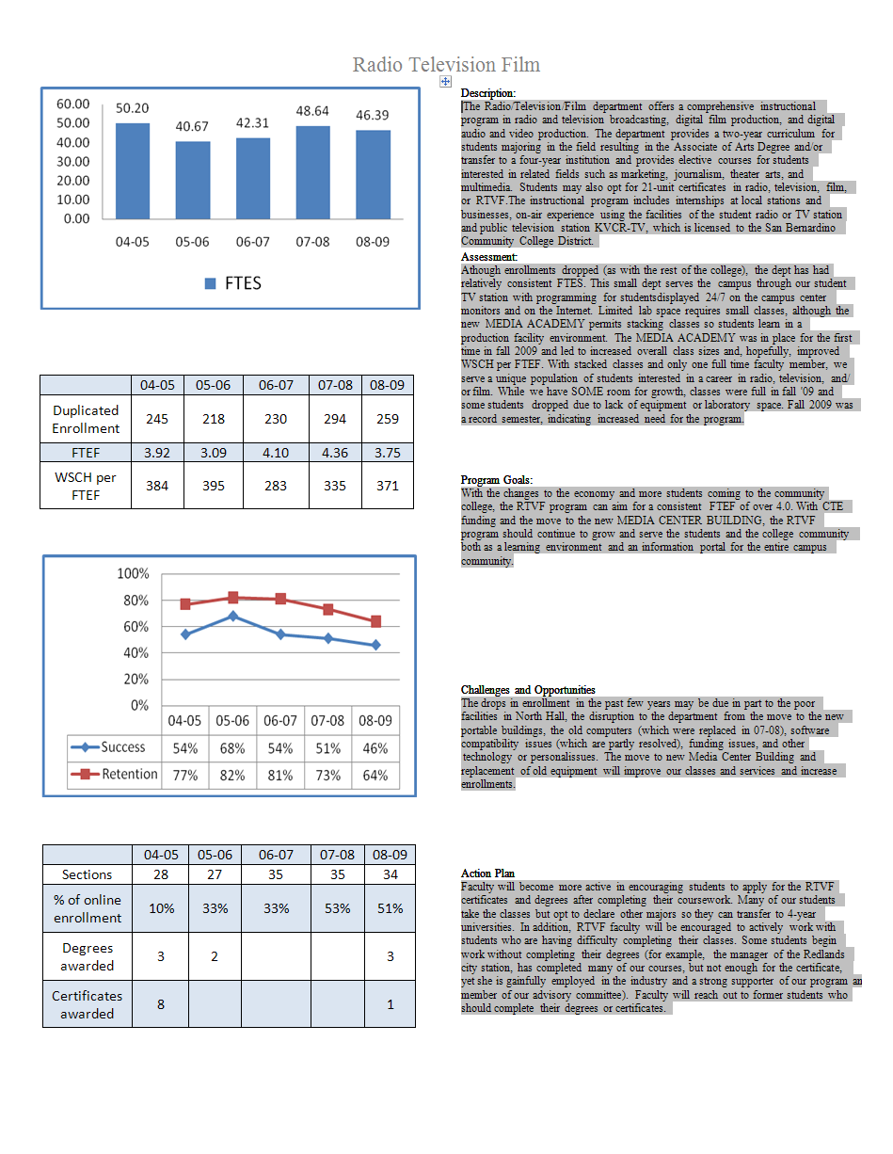
Part I. Questions Related to Strategic Initiative: Access

Use the demographic data provided to describe how well you are providing access to your program by answering the questions below.
Click here to enter text.
Does the program population reflect the college’s population? Is this an issue of concern? If not, why not? If so, what steps are you taking to address the issue?

- The RTVF department serves a diverse population of learners. One unique population includes students who already have a bachelor’s degree or other training who come to take classes to learn video/audio production. Past students include graduates from Cal State San Bernardino, UCR, and other programs. Michael Agosto, a 2009-2010 student, is a typical example. Michael has a bachelor’s degree in FILM AND VISUAL CULTURE from UCR and is attending SBVC to improve his production skills. This population is served by providing them with the unique skills they require for employment. These students select only the classes they need.
The RTVF department students are primarily male Black and Hispanic students.
The RTVF department is significantly ahead of both the state average and state targets for both nontraditional participation and nontraditional completion rates.
 | State Target | State Average | RTVF Department
Nontraditional Participation | 20.27 | 34.58 | 44.44
Nontraditional Completion rates | 21.99 | 33.44 | 71.43

Women represent 45% of our population, slightly below the campus average. Our ethnicity reflects the campus distribution with some margin of error. We have a slightly higher disabled population than the campus average. Our mean age is approximately 4 years below the campus average of 29.3.
RTVF 2008 – 2009
Gender | Frequency | Dept. Percent | Campus Pct.
Female | 241 | 45.4 | 55.71%
Male | 288 | 54.2 | 43.66%
Total | 531 | * | *
Ethnicity | Frequency | Dept. Percent | Campus Pct.
Asian | 9 | 1.7 | 4.42%
Black | 177 | 33.3 | 20.50%
Filipino | 8 | 1.5 | 1.84%
Hispanic | 159 | 29.9 | 42.90%
Nat Amer | 9 | 1.7 | .93%
Other | 6 | 1.1 | .95%
Pac Islander | 2 | .4 | .72%
White | 131 | 24.7 | 22.48%
X-undeclared | 23 | 4.3 | 5.26%
Total | 531 | * | *
Disability | Frequency | Dept. Percent | Campus Pct.
Non-disabled | 498 | 93% | 95.5%
Disabled | 33 | 7% | 4.5%
Total | 531 | 100.0

Average Age | N | Youngest | Oldest | Avg. Age Dept | Avg. Age Campus
 | 531 | 17 | 67 | 25.85 | 29.3

Pattern of Service
How does the pattern of service and/or instruction provided by your department serve the needs of the community? Include as appropriate hours of operation/pattern of scheduling, alternate delivery methods, weekend instruction/service.

Currently classes are offered in lecture and laboratory combinations Monday through Thursday 8:00 a.m. – 4:00 p.m. Lecture only classes are offered online. In fall, one lecture class is offered in the evening on campus. We have offered evening laboratory classes but they have not filled sufficiently to justify being offered. We did attempt weekend laboratory classes several years ago but again had enrollment problems. Currently, the daytime Monday-Thursday offering has met current student needs.
The RTVF program stacks 4 sets of laboratory classes: radio production classes, studio production classes, field production/editing classes, and film production/lighting-cinematography. In addition to ensuring that all classes will have enough students so classes can be offered every semester and students will have the classes for graduation, the stacking provides several additional benefits to students:
1. Beginning students ‘stacked’ with advanced students have ‘peer educators’ who can provide additional tutoring and learning opportunities. This is consistent with Vygotsky’s “scaffolding” theory of learning.
2. Having students in different classes working together provides a ‘production facility’ environment, allowing lighting/cinematography students to crew for acting/directing students.
The RTVF Department has a core persistence rate of 96.3%, compared to the state average of 84.15%, and is above the state persistence rate of 85.54%.

Part II: Questions Related to Strategic Initiative: Student Success
Provide a brief analysis of the data and narrative from the program’s EMP Summary and discuss what it reveals about your program.
Enrollments were down for two consecutive years, from 06-07 to 07-08.
The program high was 395 in 05-06, and back up to 371 in 08-09. While there are no specific data to indicate why enrollments were down, the environment in the basement of North Hall, which included a computer laboratory with no air conditioning (making teaching near-impossible on hot days), flooding during rainy days, and old computers that were not fully capable of handling the software, could all have contributed to lower enrollments.
Enrollments in fall ’08 totaled 102 for 13 sections, while enrollments in fall ’09 were 155 for 12 sections, indicating a significant increase. This increase was clearly due to the changes in the economy.
Enrollments in spring ’08 totaled 167 for 15 sections and 157 for 15 sections, indicating a slight decrease. This decrease may have been attributed to the move to the temporary buildings and some of the construction on campus.
Supplemental Data
Provide any additional information such as job market indicators, standards in the field or licensure rates that would help the committee to better understand how your program contributes to the success of your students.
From the bureau of labor statistics (http://www.bls.gov/oco/cg/cgs038.htm):
- Keen competition is expected for the more glamorous, high-paying jobs—writers, actors, producers, and directors—but better job prospects are expected for multimedia artists and animators, film and video editors, and others skilled in digital filming and computer-generated imaging.
- Small or independent filmmakers may provide the best job prospects for new entrants.
- Although many films are shot on location, employment is centered in several major cities, particularly New York and Los Angeles.
- Many workers have formal training, but experience, talent, creativity, and professionalism are the factors that are most important in getting many jobs in this industry.
Wage and salary employment in the motion picture and video industries is projected to grow 14 percent between 2008 and 2018, compared with 11 percent growth projected for wage and salary employment in all industries combined.
Job prospects. Opportunities will be better in some occupations than in others. Computer specialists, multimedia artists and animators, film and video editors, and others skilled in digital filming, editing, and computer-generated imaging should have the best job prospects. There also will be opportunities for broadcast and sound engineering technicians and other specialists, such as gaffers and set construction workers. In contrast, keen competition can be expected for the more glamorous, high-paying jobs in the industry—writers, actors, producers, and directors—as applicants outnumber available jobs. Small or independent filmmakers may provide the best job prospects for new entrants, because they are likely to grow more quickly as digital technology cuts production costs.

Student Learning Outcomes
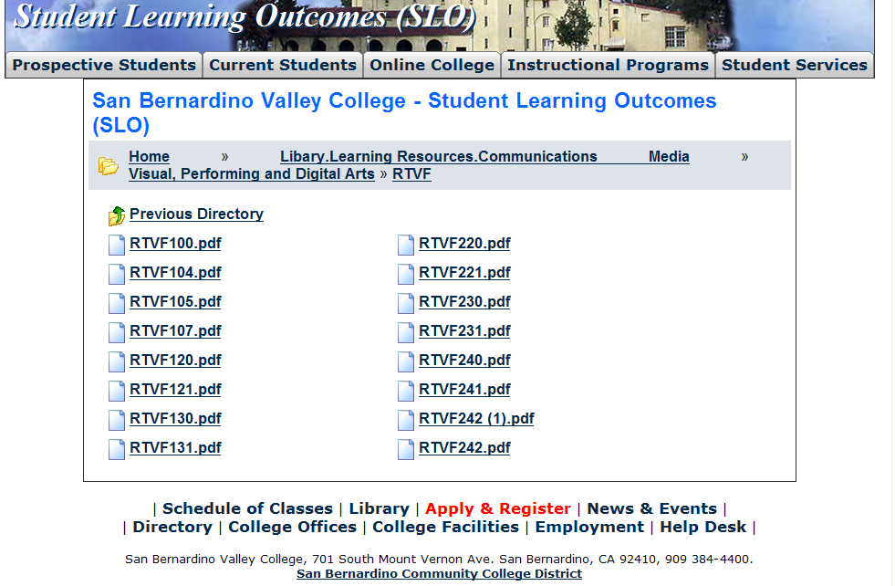
The list above shows the courses that have SLOs on file with the Office of Instruction.

If you have courses for which SLOs have not been developed, explain why. What are your plans to remedy this?
It appears the SLOs for the new courses (as of fall 2009) have not been entered into this database, but are recorded in curricunet (as required when the courses were created). These courses are 101, 132, 133, 134.

Attach your three-year plan for assessing SLOs.

What progress has the program made in its three-year plan? Have you implemented any program changes based on assessment results?

In fall 2008, 121, 131, and 140 were assessed. In spring 2009, 130, 230, and 231 were assessed. In fall, 2009, 132, 133, and 134 were assessed. In fall 2009, changes were made to the curriculum based on previous assessments, including revising all lecture/lab combination classes from 1 hour lecture/6 hours lab to 2 hours lecture/3 hours lab to accommodate a more scholarly tone to the classes. Also, the RTVF MEDIA ACADEMY was implemented to encourage students to work as a production team within the department rather than in isolated classes. Faculty are encouraged to maintain contact with students to encourage retention. Finally, the new lighting class, 132, was sent back to curriculum to revise the course work to more closely align with students’ need to understand the relationship between the director of photography and the lighting needs of a production.

Part III. Questions Related to Strategic Initiative: Institutional Effectiveness
Mission and Purpose
What is the purpose of the program?

The Radio/Television/Film department offers a comprehensive instructional program in radio and television broadcasting, digital film production, and digital audio and video production for use in broadcasting, cablecasting, multimedia, and Internet applications.
The Instructional Program offers comprehensive coursework in 4 tracks (Radio, Television, Film, or general RTVF concentration) that can be taken independently to complete 21-unit certificates or in conjunction with General Education and Electives courses for a 60-unit A.A. degree.

How does this purpose relate to the college mission?

“San Bernardino Valley College provides quality education and services that support a diverse community of learners.” In the RTVF department, we provide quality education and services to prepare students for diverse careers in radio, television, film, and multimedia.

Productivity
Provide additional analysis and explanation of the productivity data and narrative in the EMP Summary, if needed.
Retention is the biggest problem in RTVF, often because students do not realize the academic rigor of the program, sometimes thinking this is an ‘easy’ program where students just come to ‘play’ with equipment. We currently have an active Broadcasting Society where the students themselves are actively recruiting other students in the department and sharing their knowledge with each other. The broadcasting club sponsors field trips, guest speakers, and participates in campus events. This active club is working to assist faculty in retaining students.
The conditions in North Hall contributed somewhat to our low enrollments – poor conditions included no air conditioning and flooding when it rained (followed by mold).
Our stacked laboratory classes should be limited to 20 students to ensure that students can be productive and participate in all productions. Currently, our stacked classes average more than 20. For example, the 132/134240/221 stacked classes in spring 2010 have a combined enrollment of 27; the 131/133 stacked classes in spring 2010 have a combined enrollment of 28. We keep the number of seats available in stacked classes higher than what the enrollment should be for several reasons: 1. First, the enrollment in any given section may vary significantly from semester to semester depending on student needs (for example, one semester the editing class may have higher enrollment, another semester the field production may have the higher enrollment), and 2. To ensure sufficient enrollment despite attrition.

Relevance and Currency, Articulation of Curriculum
If applicable to your area, describe your curriculum by answering the following questions.
Radio, Television & Film
 |  | Course | Status | Last Content Review | Next Review Date
 |  | RTVF098 Radio, Television, and Film Work Experience | Launched | 04/15/2004 | 04/15/2010
 |  | RTVF100 Intro Radio, Television & Film | Historical | 04/15/2003 | 04/15/2009
 |  | RTVF100 Introduction to Electronic Media | Active | 03/24/2008 | 03/24/2014
 |  | RTVF101 Introduction to Cinema | Active | 03/24/2008 | 03/24/2014
 |  | RTVF102 Announcing and Performing in Electronic Media | Active | 03/24/2008 | 03/24/2014
 |  | RTVF104 Basic Writing for Broadcasting | Active | 03/24/2008 | 03/24/2014
 |  | RTVF104 Basic Writing for Broadcasting | Historical | 04/15/2003 | 04/15/2009
 |  | RTVF105 Radio and Television Advertising | Historical | 04/15/2003 | 04/15/2009
 |  | RTVF105 Radio and Television Advertising | Active | 03/24/2008 | 03/24/2014
 |  | RTVF106 Writing for Television & Film | Historical | 04/15/2003 | 04/15/2009
 |  | RTVF106 Media Writing | Active | 03/24/2008 | 03/24/2014
 |  | RTVF107 Introduction to Communications Technology | Active | 03/24/2008 | 03/24/2014
 |  | RTVF107 Introduction to Communications Technology | Historical | 04/15/2005 | 04/15/2011
 |  | RTVF120 Intro to Radio Production | Historical | 04/15/2003 | 04/15/2009
 |  | RTVF120 Introduction to Audio Production | Active | 03/24/2008 | 03/24/2014
 |  | RTVF121 Digital Audio Post Production | Active | 03/24/2008 | 03/24/2014
 |  | RTVF121 Introduction to Digital Audio | Historical | 04/15/2003 | 04/15/2009
 |  | RTVF130 Introduction to Studio Production | Active | 03/24/2008 | 03/24/2014
 |  | RTVF130 Introduction to Studio Production | Historical | 04/15/2003 | 04/15/2009
 |  | RTVF131 Digital Video Editing | Active | 03/24/2008 | 03/24/2014
 |  | RTVF131 Intro to Digital Video | Historical | 04/15/2003 | 04/15/2009
 |  | RTVF132 Lighting for Stage and Screen | Active | 03/24/2008 | 03/24/2014
 |  | RTVF132 Lighting and Cinematography | Launched | 03/24/2008 | 03/24/2014
 |  | RTVF133 Video Field Production | Active | 03/24/2008 | 03/24/2014
 |  | RTVF134 Acting and Directing for Television and Film | Active | 03/24/2008 | 03/24/2014
 |  | RTVF198 Radio, Television, and Film Occupational Work Experience | Active | 04/15/2004 | 04/15/2010
 |  | RTVF220 Intermediate Radio Station Operations | Active | 03/24/2008 | 03/24/2014
 |  | RTVF220 Intermediate Radio Production and Operations | Historical | 04/15/2003 | 04/15/2009
 |  | RTVF221 Radio Station Management | Historical | 04/15/2003 | 04/15/2009
 |  | RTVF221 Broadcast Station Management | Active | 03/24/2008 | 03/24/2014
 |  | RTVF222 Independent Study in Radio/Television/Film | Active | 04/15/2003 | 04/15/2009
 |  | RTVF222 Independent Study in Radio/Television/Film | Historical | 04/15/2003 | 04/15/2009
 |  | RTVF230 Intermediate Studio Production | Historical | 04/15/2003 | 04/15/2009
 |  | RTVF230 Intermediate Studio Production | Active | 03/24/2008 | 03/24/2014
 |  | RTVF231 Advanced Video Production | Historical | 04/15/2003 | 04/15/2009
 |  | RTVF231 Advanced Video Production | Active | 04/15/2003 | 04/15/2009
 |  | RTVF240 Fundamentals of Film Production I | Historical | 04/15/2003 | 04/15/2009
 |  | RTVF240 Motion Picture Production | Active | 03/24/2008 | 03/24/2014
 |  | RTVF241 Fundamentals of Film Production II | Historical | 04/15/2003 | 04/15/2009
 |  | RTVF241 Fundamentals of Film Production II | Historical | 03/24/2008 | 03/24/2014
 |  | RTVF242 Fundamentals of Film Production III | Historical | 04/15/2003 | 04/15/2009
 |  | RTVF242 Fundamentals of Film Production III | Active | 03/24/2008 | 03/24/2014

The Content Review Summary from Curricunet indicates the programs current curriculum status. If curriculum is out of date, explain the circumstances surrounding the error and plans to remedy the discrepancy.
Articulation
Curriculum is not out of date –
100% of our curriculum is articulated with CAL STATE SAN BERNARDINO.
We have articulated individual classes with other universities.

Additional schools that have articulated our courses include CSU-Fullerton:
The Bachelor of Arts in Radio-TV -Film requires a minimum of 120 units which
includes 48 units in the major, 51 units in general education, and 21 units
of open electives. Remember you need at least 40 units of upper division
coursework when selecting your electives.

RTVF CORE (9 units)
CUS-FULLERTON SBVC/RTVF
Required Lower Division:
RTVF 100 Intro to Radio-TV- Film (3)|RTVF 100 Introduction to (3)
| Electronic Media
RTVF PRODUCTION COURSE (3 units)
Required Lower Division:
RTVF 220 TV Studio Production (3)|RTVF 130 Introduction to Studio (3)
| Production
|
| OR | OR
RTVF 225 Field Video Production (3)|RTVF 231 Advanced Video (3)
| Production
| OR
|RTVF 133 Video Field Production (3)
--------------------------------------------------------------------------------
RTVF ELECTIVES (24 units)

Students choose eight courses from the RTVF elective list.

Lower Division Selection:
RTVF 210 Intro to Audio Production (3)|RTVF 121 Digital Audio Post (3)
| Production
RTVF 220 TV Studio Production (3)|RTVF 130 Introduction to Studio (3)
| Production
|
|RTVF 225 Field Video Production (3)|RTVF 231 Advanced Video (3)
| Production
| OR
|RTVF 133 Video Field Production (3)
List Courses above 100 where articulation is not occurring | With CSU | With UC
Click here to enter text. | Click here to enter text. | Click here to enter text.
Click here to enter text. | Click here to enter text. | Click here to enter text.
Click here to enter text. | Click here to enter text. | Click here to enter text.
Click here to enter text. | Click here to enter text. | Click here to enter text.

Describe your plan to articulate these classes.
Click here to enter text.

Currency
Review the last college catalogue data given below.
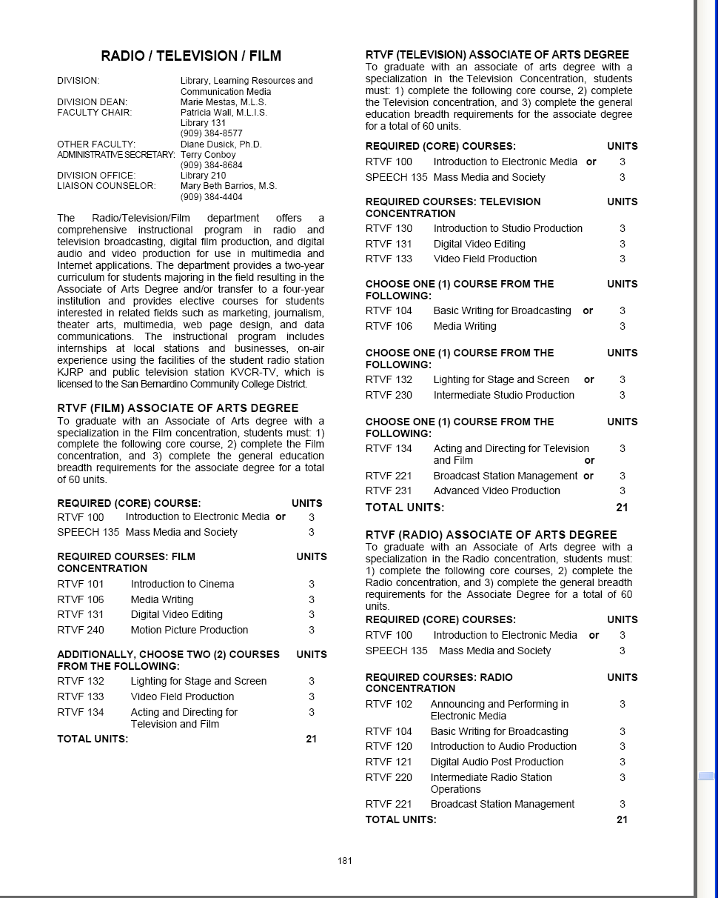
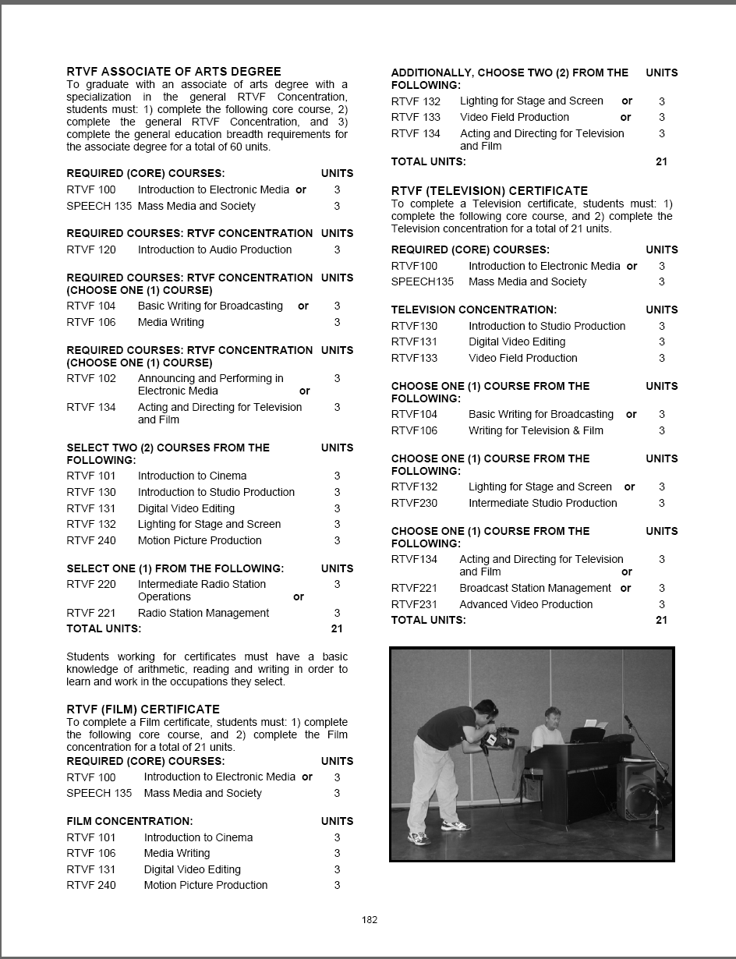
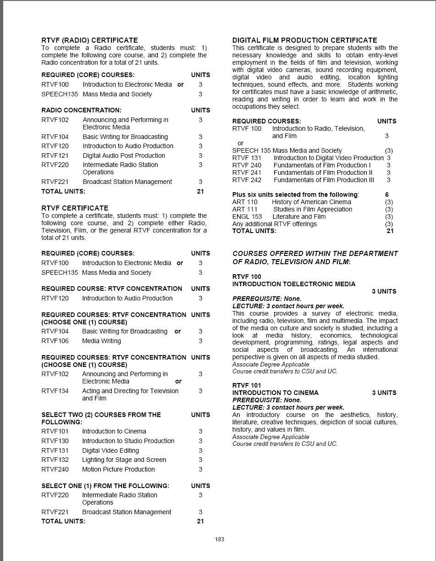
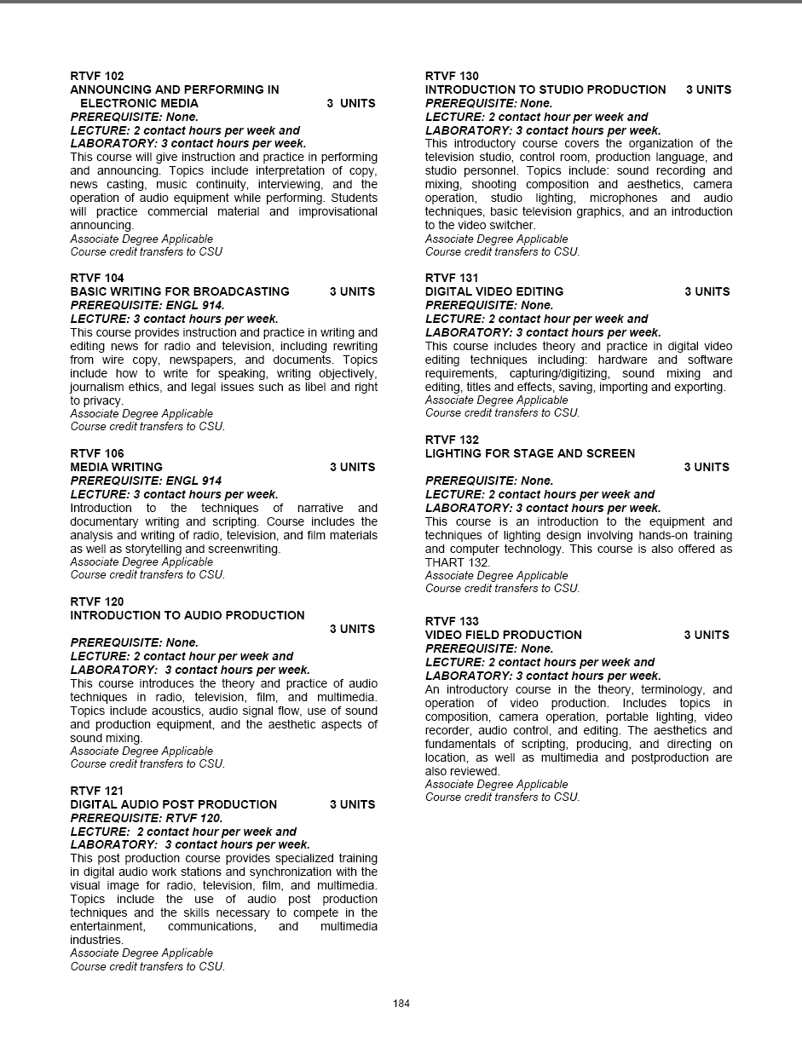
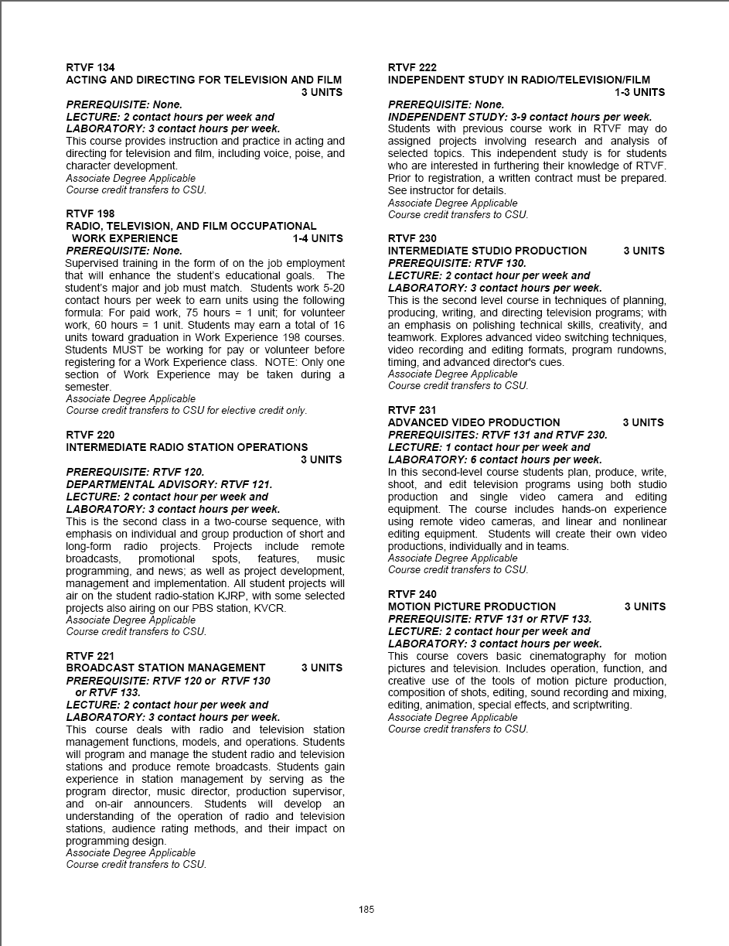

Which courses are no longer being offered? (Include Course # and Title of the Course)

All classes are currently being offered.
Click here to enter text.
Click here to enter text.
Click here to enter text.

Planning
What are the trends, external to the institution, impacting your student enrollment/service utilization? How will these trends impact program planning?
The downturn in the economy has resulted in an increase in enrollments. Many of our students come just to take a few classes and go to work or transfer without completing the program degree or certificate. We encourage students complete the degree or certificate if it fits with their plans, but some students transfer to colleges or universities that articulate only our core courses and they graduate with an A.A. in liberal arts. We continue to support (a) certificate, (b) A.A. degree, and (c) transfer with a liberal arts degree students.
Changes in technology pose a major challenge for the department. The industry is completely different from the radio, television, film industry of 1990. The transition to digital, the creation of high definition, the creation of the Internet, and compression algorithms have all contributed to the revolution in the entertainment industry. The job market changes from year to year as some jobs become less important (with the advent of high-end, less expensive video equipment, wedding videographers have less work) while video editors for television and film have more opportunities.
The first way to keep up with these major trends is to keep students informed through all classes on the changes in the industry and the possibilities for future job opportunities. In addition, curriculum is reviewed every year to ensure that we are teaching the most relevant information. Finally, we are using both college funds and Perkins grant money to keep the equipment and software as state-of-the-art as possible.
The RTVF department keeps students apprised of the job market through our department website, which includes links to 3 different job sites in the entertainment industry as well as links to the top 9 transfer universities: http://learnonline.sbccd.cc.ca.us/~RTVF/info.htm

Accomplishments and Strengths
Referencing the narratives in the EMP Summary, provide any additional data or new information regarding the accomplishments of the program, if applicable. In what way does your planning address accomplishments and strengths in the program?

The MEDIA ACADEMY is designed to give students a real-world production facility experience. To accomplish this, faculty coordinate classes to ensure that all students participate in some aspect of production, whether writing, producing, directing, acting, editing, etc. Students continue to produce real-world projects for real-world clients. In spring, 2010, a script written in RTVF 104 was produced by a student in RTVF 240, acted in by students in RTVF 134, crewed by students in RTVF 132, and edited by a student in 131. This script was requested by Congressman Joe Baca’s office and will air on KVCR in March 2010. RTVF students produce promotional videos for departments around campus that are aired on the monitors in the Campus Center and over the Internet (http://vod.sbccd.cc.ca.us/kjrp), again giving the RTVF students real-world experience.

RTVF production students create a monthly video for Health 101, that is reviewed and approved by Student Health Services staff prior to dissemination. RTVF students also work with members of the community. In spring 2010, two field production students worked with Judge Slough, Presiding Judge in San Bernardino Juvenile court to record interviews with Spanish subtitles. These types of projects not only give students real-world experiences and portfolio projects, but improve our ties with the community.

Weaknesses
Referencing the narratives in the EMP Summary, provide any additional data or new information regarding planning for the program. In what way does your planning address trends and weaknesses in the program?
This is a costly program, so it is critical that, in addition to college support, the RTVF department retains funding through the Carl Perkins grant. The move to the new Media Center building will contribute to the growth and visibility of the department, allowing us to serve more students as the economy grows and the need for more highly trained media specialists continues.

We have faced serious challenges with enrollments in the past few years as well as poor facilities and equipment. We had to move to a temporary building for 1 ½ years, and now face another move. However, once situated in the new Media Communications Building, we will have newer equipment, better facilities, and more visibility in the community.

V. Questions Related to Strategic Initiative: Technology, Campus Climate and Partnerships.

Describe how your program has addressed the strategic initiatives of technology, campus climate and/or partnerships.
An articulation agreement was recently signed with Arroyo HS, and negotiations began in spring 2010 with Big Bear HS to articulate the classes in their film program. The RTVF department contributes significantly to the campus climate by promoting events on the campus center monitors and over the Internet, RTVF students also produce training or informational videos (for example, monthly informational videos for the Student Health 101 website.).
We continue to work with members of the community, as evidenced by the projects done in spring 2010 for congressman Joe Baca and Judge Slough of the San Bernardino Juvenile court. We have an ongoing relationship with KVCR and use the KVCR production facility for our primary video production classroom.

